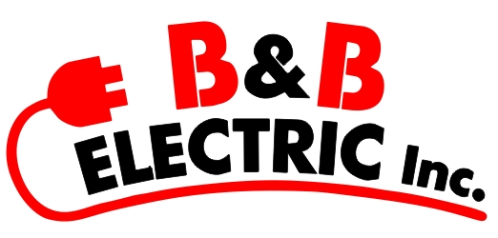
1303 Western Ave.
Eau Claire WI. 54703
(715) 832-1676 Fax (715) 832-1677
www.bandbelectric.com
Equal opportunity employer

Company Overview/Job Summary
B&B Electric Inc, a highly sought out electrical contractor and is seeking a Project Manager to join our team. The Project Manager is responsible for managing multiple projects, project coordination, job scheduling, quality control, problem resolution, job invoicing, job payments, job completion and customer satisfaction.

Responsibilities and Duties
- Complete all bids, documents, and reports in an accurate, complete, and professional manner.
- Plan all projects to optimize the efficiency of labor, materials, supplies, equipment, and tools.
- Negotiate and resolve issues related to Change Orders, Requests for Information, Contract Scope of Work in a timely manner.
- Interface with the customer throughout jobs and attend customer meetings as requested or needed to provide job updates, progress status, and resolve issues.
- Follow up with customer to ensure all expectations have been met and measure overall performance satisfaction.
- Manage all closeout procedures including documentation filing, record drawings, construction cost database input, follow-up marketing, and team debriefing.

Summary of Qualifications
- A keen understanding of the electrical construction industry with 1-3 years’ experience working within the industrial and manufacturing markets.
- Must have general PC skills including email, internet, data entry and Microsoft Office.
- Ability to multi-task in a high volume, fast-paced work environment.
- Effective communication, troubleshooting, and problem-solving skills.
- Exposure to McCormick Estimating Software is a plus.
- History of a strong client relations and people management skills.

Employee Benefits
- Paid Holidays
- Vacation
- Retirement Package
- Health Insurance

To Apply
Please submit a cover letter and a resume to jr@b-belectricinc.com

